**DAILY ONLINE ACTIVITIES SUMMARY**

|  |  |  |  |  |  |  |  |  |
| --- | --- | --- | --- | --- | --- | --- | --- | --- |
| **Date:** | **10/06/2020** | | | | | **Name:** | **Varshitha Makam** | |
| **Sem & Sec** | **8th B** | | | | | **USN:** | **4AL16CS118** | |
| **Online Test Summary** | | | | | | | | |
| **Subject** | | **Not conducted** | | | | | | |
| **Max. Marks** | |  | | **Score** | | |  | |
| **Certification Course Summary** | | | | | | | | |
| **Course** | **Robotics Process Automation** | | | | | | | |
| **Certificate Provider** | | | **GUVI** | | **Duration** | | | **3 hours** |
| **Coding Challenges** | | | | | | | | |
| **Problem Statement:** | | | | | | | | |
| **Status: Completed** | | | | | | | | |
| **Uploaded the report in Github** | | | | | **yes** | | | |
| **If yes Repository name** | | | | | **Varshithamakam**  **https://github.com/alvas-education-foundation/varshithamakam** | | | |
| **Uploaded the report in slack** | | | | | **yes** | | | |

Online Test Details:

Not conducted

Certification Course Details:

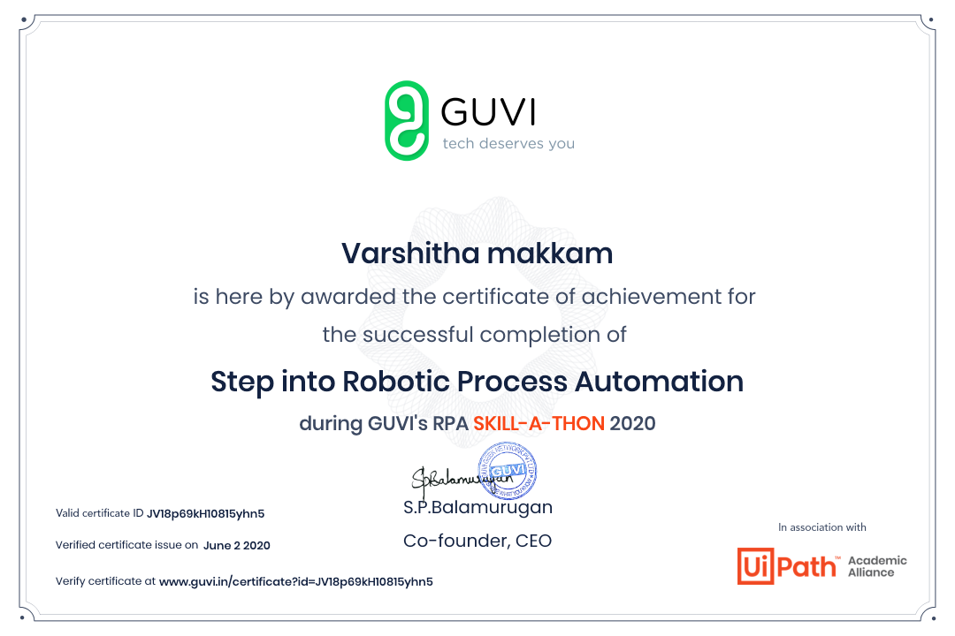

Coding Challenges Details:

**Python program to calculate length of a String without using len() function**

# User inputs the string and it gets stored in variable str

str = input("Enter a string: ")

# counter variable to count the character in a string

counter = 0

for s in str:

counter = counter+1

print("Length of the input string is:", counter)